
PATUAKHALI SCIENCE AND TECHNOLOGY UNIVERSITY

COURSE CODE CCE 312
Numerical Methods Sessional

SUBMITTED TO:

Prof. Dr. Md Samsuzzaman

Department of Computer and Communication Engineering
Faculty of Computer Science and Engineering

SUBMITTED BY:
Md. Sharafat Karim
ID: 2102024,
Registration No: 10151
Faculty of Computer Science and Engineering

Assignment 18
Assignment title: Secant Method
Date of submission: 08 Wed, Oct 2025

Problem Statement
Background:
A pharmacodynamics research team is modeling the concentration of a new heart medication in the bloodstream over time. The drug's effectiveness is directly related to its steady-state concentration, where the rate of administration equals the rate of elimination. The model for the steady-state concentration C (in mg/L) is derived from a nonlinear pharmacokinetic equation.
The Challenge:
After simplifying the complex biological model, the team arrives at the following equation that must be solved for the steady-state concentration C:
C²−2=0

Code
# Our function
def f(x):
return x**2 - 2

def secant_method(f, x0, x1, tol=1e-7, max_iter=100):
for i in range(max_iter):
if abs(f(x1)) < tol:
return x1
if f(x1) == f(x0): # Prevent division by zero
print("Division by zero encountered in secant method.")
return None
# Secant method formula
x2 = x1 - f(x1) * (x1 - x0) / (f(x1) - f(x0))
x0, x1 = x1, x2
print("Maximum iterations reached without convergence.")
return None

print(secant_method(f, 1, 2))
root = secant_method(f, 1, 2)

# Let's plot the result
x = np.arange(0, 3, 0.1)
plt.plot(x, f(x), label='f(x) = x^2 - 2')
plt.scatter(root, f(root), color='blue') # Mark the root on the plot
plt.axvline(root, color='purple', linestyle='--', label=f'x = root ({root:.5f})')

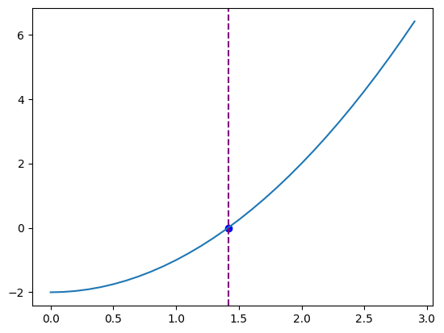
Visualization

Result

X = 1.4142135620573204

